Cold vs Warm Fronts Worksheet

A **cold front** is a moving mass of cold air that pushes into a warmer air mass. The cold air pushes under the warm air and makes it move up and out of the way. The front is the place where the two air masses meet. There is usually some rain or snow when a cold front moves in, but it generally does not last for a long time. The skies will clear and you will have colder weather for a while.

A **warm front** is a moving mass of warm air that pushes into a colder air mass. The warm air is lighter and moves in on top of the cold air. The cold air gets pushed slowly off to the side. The slope of a warm front is very gradual, since it does not move in quickly. There will be some cirrus clouds at the beginning, then stratus clouds, and closest to the ground some nimbostratus clouds. These bring rain for several days. The weather is usually warmer and more humid after a warm front moves by.

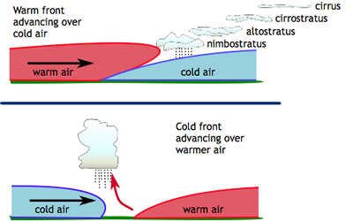

Highlight in blue the sentences that describe a cold front. Highlight in red the sentences that describe a warm front. Not all of them will be highlighted.

1. A cold front is a moving mass of cold air.
2. A warm front is a mass of warm air that moves into a region that has cooler air.
3. In a cold front, the cold air moves in on top of warm air and pushes it off to the side.
4. When a cold front moves in you will experience rain for many days.
5. After the rain clears, you will have warmer weather for a while with a warm front.
6. The edge or slope of a warm front is very gradual.
7. The symbol for a warm front is a row of dark, rounded bumps.
8. The symbol for a cold front is a row of solid triangles.
9. After a cold air mass has moved in, the skies will clear and you will have much warmer weather.
10. Cirrus clouds form as a warm front just begins to move in.